Standard Operating Procedures: VISA

Visa Application Guidance
  - Travel Management Division Support for Federal Travelers
The Travel Management Division is committed to assisting federal employees with the passport and visa application process. Our guidance is designed to streamline your preparations and ensure timely documentation for official travel.

VISA Submission Guidance
To ensure a smooth visa application process, please submit all required documentation to the Travel Management Division (TMD) through Kiteworks before scheduling an appointment via Travel Management Division (office365.com). TMD will review your application and notify you if any issues are found or if additional information is needed.
Employees are responsible for delivering completed visa applications to the designated embassy or consulate, unless otherwise instructed by the Travel Management Division. Our team will provide embassy contact information and support throughout the process.
For country specific information, U.S. Visas.
Step-By-Step Guide for Applying for a Visa
1. Greet all Applicants.
Advise the applicant to read the Travel Advisory for the desired country.
2. Apply for Diplomatic Note (DipNote)
Collect
- Memorandum
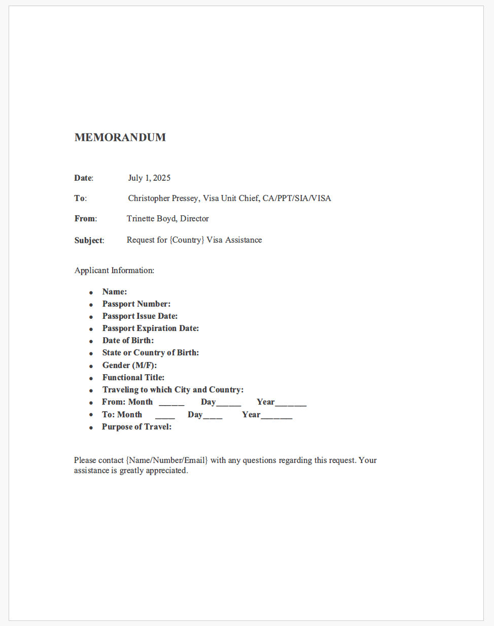
- Copy of the official Passport Bio Page
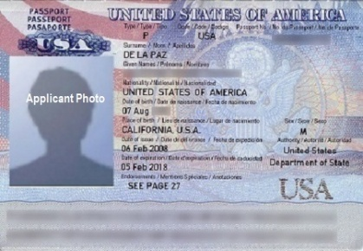
3. Submit documents to State Department (SIA): ca-ppt-sia-visa-letters@state.gov
NOTE: DipNote takes 24 hours to process.
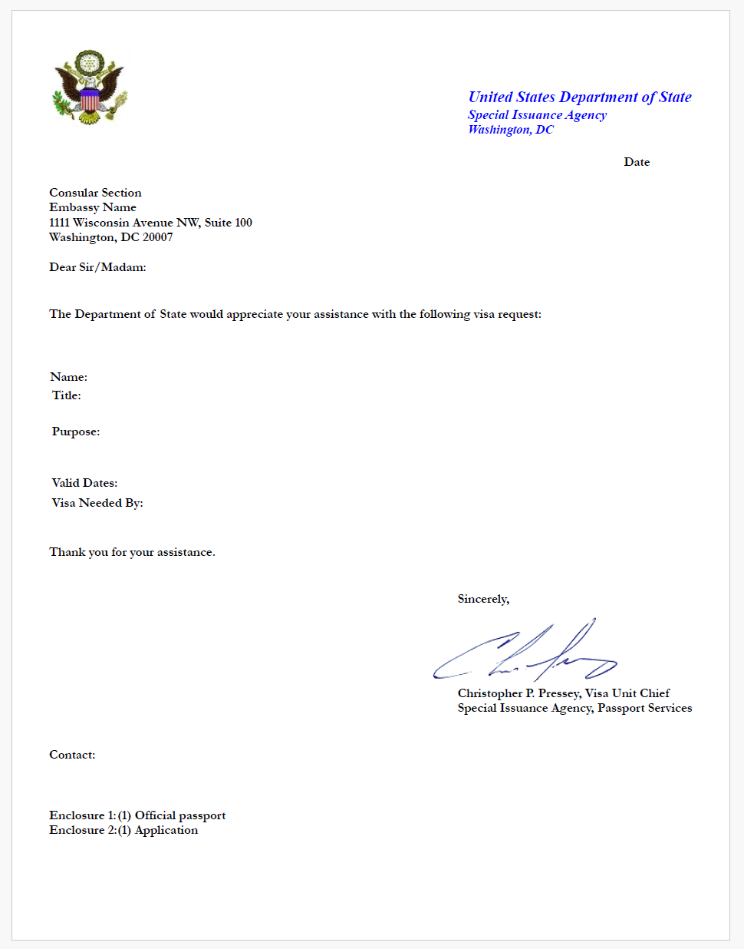
4. Submit the following documents to the country of choice:
- DipNote
- Country’s required application
- 1 2x2 passport photo
- Passport
For countries that require digital submission, the traveler will send the completed package along with the DipNote to the Embassy directly.
NOTE: For countries that do not require digital submission, the courier will retrieve the packet and deliver to the embassy (same day of pick up).
5. Ticket retrieval
- Courier returns with a ticket from the embassy reflecting date and time for pick up.
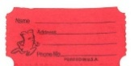
6. On the appointed day and time, courier retrieves tickets from TMD for VISA pick up from embassy.
7. Upon same day return, applicants are contacted to schedule an appointment for passport VISA pick up.
NOTE: Each embassy varies in how visas requests are processed and should be reviewed before submission for:
- Application
- Processing time
- Travel Advisory
*Note: For urgent VISA request if you are travelling in 7 days or less:
The Travel Management Division will require your application, photos and travel order be brought to Room D-100:

TMD’s Responsibillity
- Will contact State for DipNote

- Upon receipt of the DipNote from the State, TMD will contact Embassy for availability for VISA dropoff

Traveler’s Responsibility
- Due to courier’s availability, the traveler will be given the address of the Embassy and the hours that are allowed to drop off the visa application package.

- If courier is available, the VISA package could be transported directly from TMD along with the DipNote to Embassy, however, TMD should be notified that is Traveler’s preference.

Processing Timelines

- Department of State prepares the DipNote within 24 hours upon receiving the request.

- VISA approvals are subject to country/embassy specific guidelines, with no guarantee for expedited service (i.e., 5-days for Japan, 7-days for Brazil, up-to-10 days for Peru, up-to 20 days for Russia).

Special Instructions for USPTO, NOAA, and CENSUS Employees
Employees of the United States Patent and Trademark Office (USPTO), National Oceanic and Atmospheric Administration (NOAA), or the Census Bureau must follow agency-specific procedures for visa applications. Please consult your agency’s travel coordinator for additional requirements and submit documentation as directed.

Contact Information
For further clarification or support, please contact the Travel Management Division at OFM-DOCPassportVisaHelpdesk@doc.gov or call (202) 482-1818. Our team is available Monday through Friday, 8:00 AM–3:30 PM.

