Standard Operating Procedures: Passport

Passport Submission Guidance
To ensure a smooth passport application process, please submit all required documentation to the Travel Management Division (TMD) through Kiteworks before scheduling an appointment via Travel Management Division (office365.com). TMD will review your application and notify you if any issues are found or if additional information is needed.
Applicants are advised to fill out all forms completely and legibly to prevent delays in processing. Incomplete or unclear forms may result in your application being returned for correction.
Documents may be delivered in person, sent via secure courier, or electronically submitted for select forms, with eligibility for electronic submission confirmed by contacting the office. If you have questions about submission options or whether your forms qualify for electronic delivery, please contact the Travel Management Division for guidance.
Application for a U.S. Passport, must be executed before an authorized Acceptance Agent.
Step-By-Step Guide to Accepting a Passport Application
1. Greet all Applicants.
Advise the applicant to read the Privacy Act Statement on page 4 of Form DS-11.
2. Collect Form DS-11 and Accompanying Documents
- Form DS-11
- 2 2x2 passport photos (no older than 6 months)
- Photocopy of identification (verify that it is the same ID that has been presented, with both the front and back of the ID document)
- Evidence of U.S. citizenship
- Photocopy of U.S. citizenship
- Additional documentation (if necessary).

NOTE: the DS-11 must be printed as a full-size image on single-sided 8.5 x 11-inch sheets of paper. No double-sided papers are permitted. Copies of the ID and citizenship evidence must also be printed on single-sided 8.5 x 11-inch sheets of paper.
3. Review Application
- Ensure the application is completed in black ink
- Review the application for completeness, accuracy, and legibility (if the application is illegible, have the applicant complete a new application)
4. Verify the Identity of the Applicant and compare the following to confirm all are the same person:
- Look at the applicant’s face
- Look at the passport photo
- Look at the photo on the ID
- Look at the image on the photocopy of the ID and verify that the photocopy is a true, accurate, and clear copy of the original ID
5. Staple the Photo to Form DS-11 Within the Space Provided
- Ensure that the photo meets the requirements
- Attach one photo with four staples, one in each corner
6. Review Evidence of U.S. Citizenship
- Examine document(s) (birth certificate, naturalization certificate, etc.) to ensure it is acceptable (parents’ names must appear on birth certificates for all applicants, regardless of age)
7. Identification Documents – record the following:
- Type of ID (Driver License, State ID, etc.)
- Full name exactly as it is displayed on the ID
- Issuance and expiration dates
- Place of issuance
8. Administer Oath
- Administer the oath to the applicant by raising your right hand and stating, “Do you swear or affirm that the statements in the application are true and correct and that the photograph is a genuine, current photograph of you?”
9. Witness the Applicant’s Signature
- The applicant must sign the application in the appropriate box in the presence of the Acceptance Agent.
- If the applicant already signed the form before the oath was administered, the applicant must neatly strike through the original signature and then re-sign the form.
10. Complete the Application
- Sensitive but Unclassified (SBU)
- Sign and date the application
- Affix your facility’s seal or stamp
- Record your Acceptance Facility and Agent ID Number
- Record your Acceptance Facility name and location
- Check “Acceptance Agent” box
- Return Form DS-11 instruction sheet(s) to the applicant for their records
If any of this information is missing, the application is NOT a valid, executed document.
11. Assemble the Application
12. Store the Application and Documents in a Secure Location
NOTE: Incomplete applications should not be held at Acceptance Facilities pending additional documentation under any circumstances. Applicants who cannot submit all required documents should return when a complete application package can be accepted. Do not return a partially executed passport application (i.e., partially completed jurat section) to the applicant. The application must be shredded, and the applicant must complete a new passport application.
- Make sure that applications and documents are out of public view and reach
- Applications and documents must be stored under lock and key when away from workstation
13. Prepare the Applications for Courier drop-off
- Separate Routine and Expedite applications
- Complete separate transmittals for Routine and Expedite applications
- Verify that all applications are completely and accurately recorded on the appropriate transmittal form
- Print and sign your name on the transmittal and affix your facility’s seal in the appropriate locations
- Make a copy of each complete transmittal form for your records (copies must be maintained by your facility under lock and key for 24 months)
- Place each transmittal and the corresponding applications into an appropriately addressed envelope/green bag
- Turn green bag over to Courier for State Dept. delivery

Completing the Forms
DS-11, Application for U.S. Passport
Form DS-11, Application for a U.S. Passport, comprises six pages: four Instruction Pages and two Application Pages. Applicants may obtain this form online at U.S. Passports (TSG) or onsite at a designated passport application acceptance facility.
The DS-11 application pages must be submitted to you as two full size 8.5 X 11-inch sheets of paper. They must not be printed as a two-sided, one page form.
Form DS-11 is used by applicants who:
- Are applying for a passport for the first time
- Had their most recent previous passport lost, stolen, extensively damaged, or mutilated
- Are not eligible to use Form DS-82 to renew a valid passport
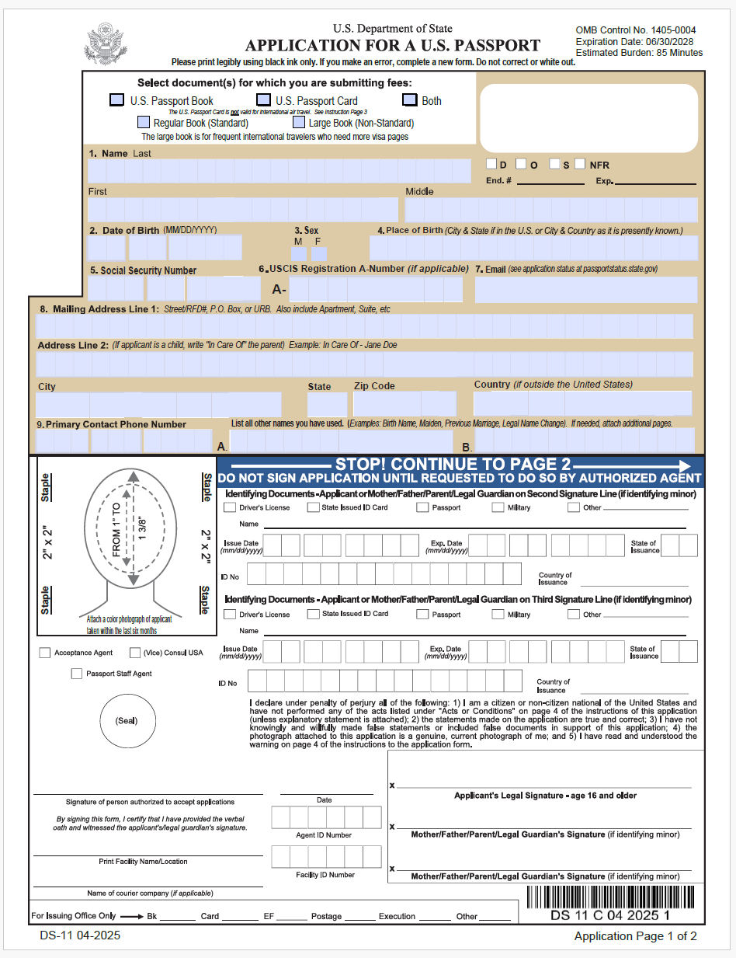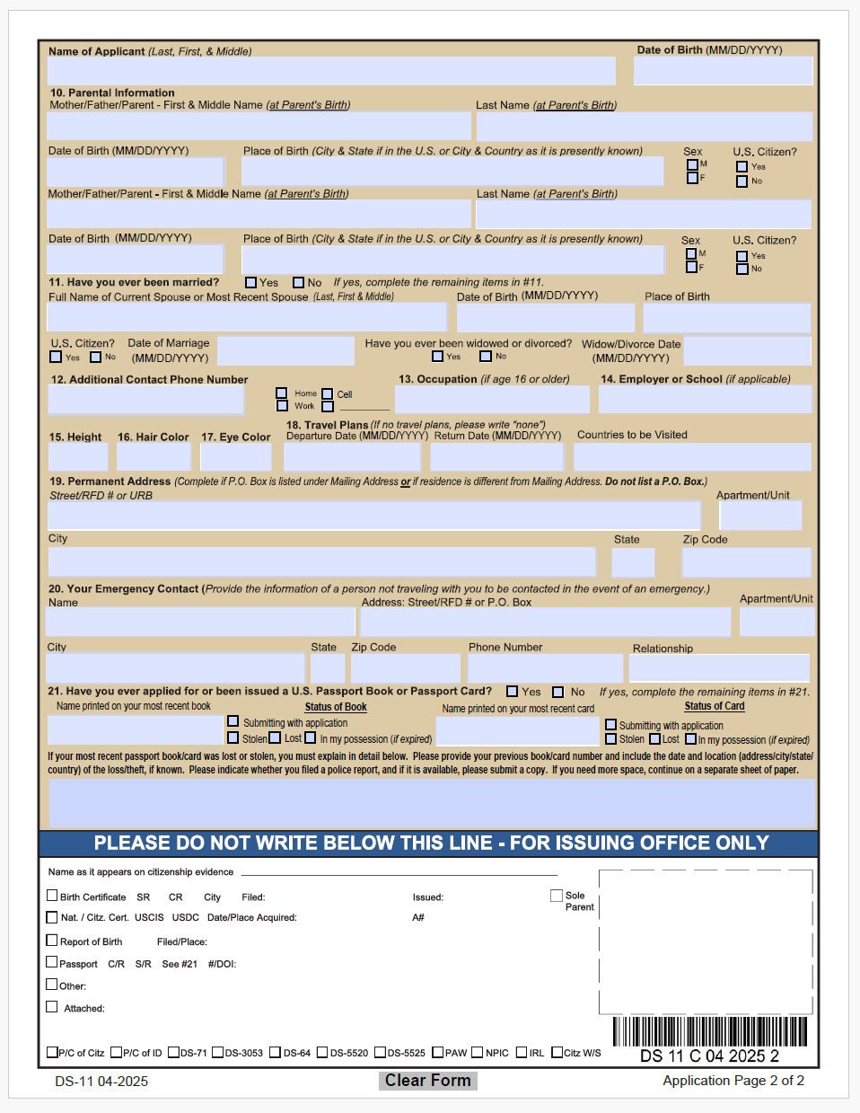

NOTE: Advise all applicants to type or legibly print IN BLACK INK ONLY to avoid processing delays.
- If a mistake is made on the application on page 1 of the DS-11, then a new page 1 is required. Crossing out information on page 1 is not acceptable. Mistakes on page 2 of the DS-11 can be neatly crossed out and corrected.
- Acceptance Agents should use dark ink to make notations on the application.
- Agents should never complete missing information for an applicant.

Form DS-82, Passport Renewal Application for Eligible Individuals
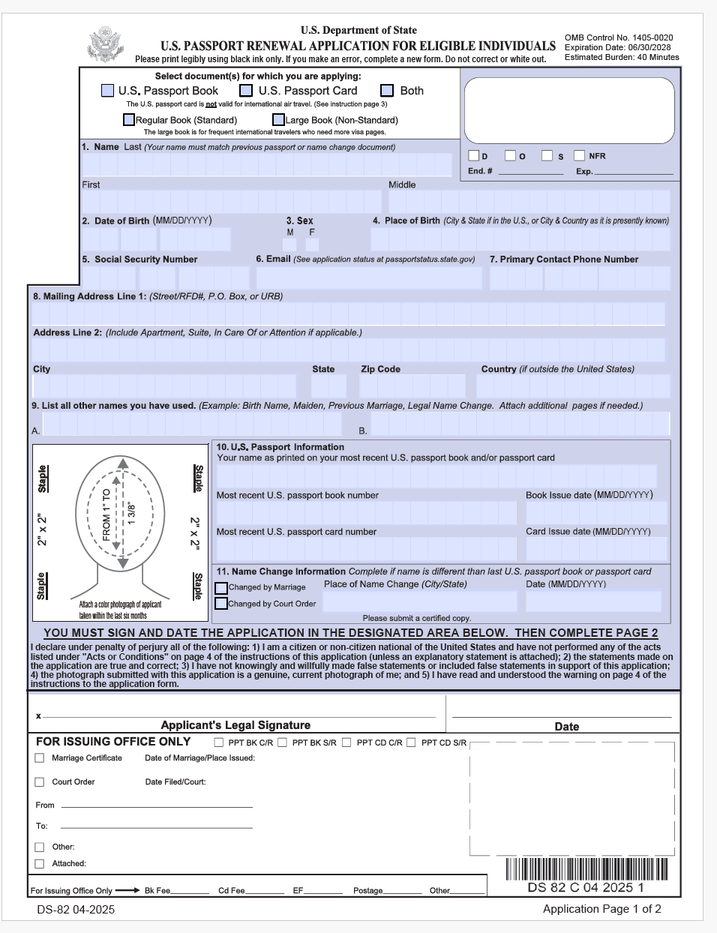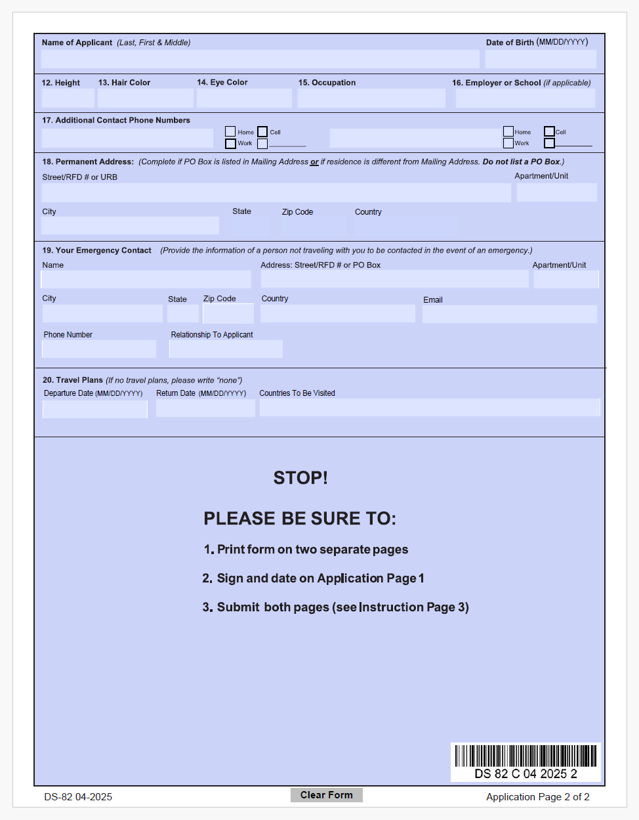
For an applicant to be eligible to use Form DS-82, they must have a passport book that:
- Is not extensively damaged or mutilated
- Was issued within the past 15 years
- Was issued when they were 16 years of age or older
- Was printed in their current name, unless they can include a marriage certificate or name change decree
If all requirements are satisfied, an applicant may use a valid passport book to apply for an official passport. If the applicant has a current, valid passport book, that book must be submitted when applying for a new book, unless the applicant is applying for a secondary official passport. If the book is expired, then the applicant may submit either document to receive either or both documents.

Expedited and Urgent Processing Procedures
If your travel is expedited, to include urgent (travel within 72 hours) processing is available. The applicant must ensure to:
- Schedule a passport appointment with TMD;
- Ensure the passport application (DS-11 or DS-82) and all accompanying documents are present for review.
- Provide the below written memo outlining your travel dates and justification. The Travel Management Division will coordinate with relevant agencies to prioritize your application.
- TMD will request the appointment with SIA, attaching all required documents. Contact the courier for transport. In the case of urgent passport requests (please see the note below), the applicant is able to travel to SIA and wait for the passport to be processed (same day).
- If the applicant receives the passport, the requesting office must notify TMD that the passport has been delivered to the applicant for passport tracking purposes.
*Note: For urgent passport requests for travel within 72 hours:
Customer Counter Referrals (Mission Critical Travel Within 72 Hours):
Additional application appointments for your agency’s courier(s)/employees will only be considered for mission-critical travel within 72 hours. In these cases, TMD or the applicant will request an appointment by emailing - CA-PPT-SIA-PASSPORTS@state.gov using the template below and attach the items listed in the “documents” field. Upon approval, SIA will reply with the appointment confirmation and further instructions.
- Memo must be completed with the following information on letterhead:
SUBJECT: URGENT 72-HR Appointment Request (Agency Name) | (LAST NAME, First Middle) | Date of Travel: (xx/xx/xxxx)
Hello SIA,
We are requesting a customer to your counter. Details are provided below.
Name
Phone Number
E-Mail
Travel Date
Destination
Application #  (If applicable) | Is this a new or existing application?
Notes
Attached Documents | Authorization document, travel orders, itinerary.
Appointment Info | We will provide the customer with appointment information when confirmed.

Once TMD has reviewed and validated that all required forms and supporting information for an urgent passport request are complete, travelers have two options: 1) TMD Submission: Work with TMD to submit the urgent passport request to the Department of State (DOS) and wait for DOS to process the request; or 2) In-Person Submission: Make an appointment, bring the completed package to DOS, and submit the request in person. In most cases, DOS should be able to process it immediately. Upon the receipt of the passport, the traveler or office must notify TMD.

Processing Timelines
Routine Passport requests can take 4-6 weeks when submission.
Expedited Passport requests can take 2-3 weeks upon submission.
Urgent Passport requests can be processed in 2-3 days.

Special Instructions for USPTO, NOAA, and CENSUS Employees
Employees of the United States Patent and Trademark Office (USPTO), National Oceanic and Atmospheric Administration (NOAA), or the Census Bureau must follow agency-specific procedures for passport applications. Please consult your agency’s travel coordinator for additional requirements and submit documentation as directed.
Contact Information
For further clarification or support, please contact the Travel Management Division at OFM-DOCPassportVisaHelpdesk@doc.gov or call (202) 482-1818. Our team is available Monday through Friday, 8:00 AM–3:30 PM.

