Department of Commerce
Standard Operating Procedure
SAM.gov Representations and Certifications
Section 889 Search
Purpose: The purpose of this Standard Operating Procedure (SOP) is to provide instructions to assist cardholders with searching for vendor Section 889 Representations before making purchases from open market sources. Steps to Search SAM.gov:
- Go to SAM.GOV
- Sign-in
- Click “Entity Information”
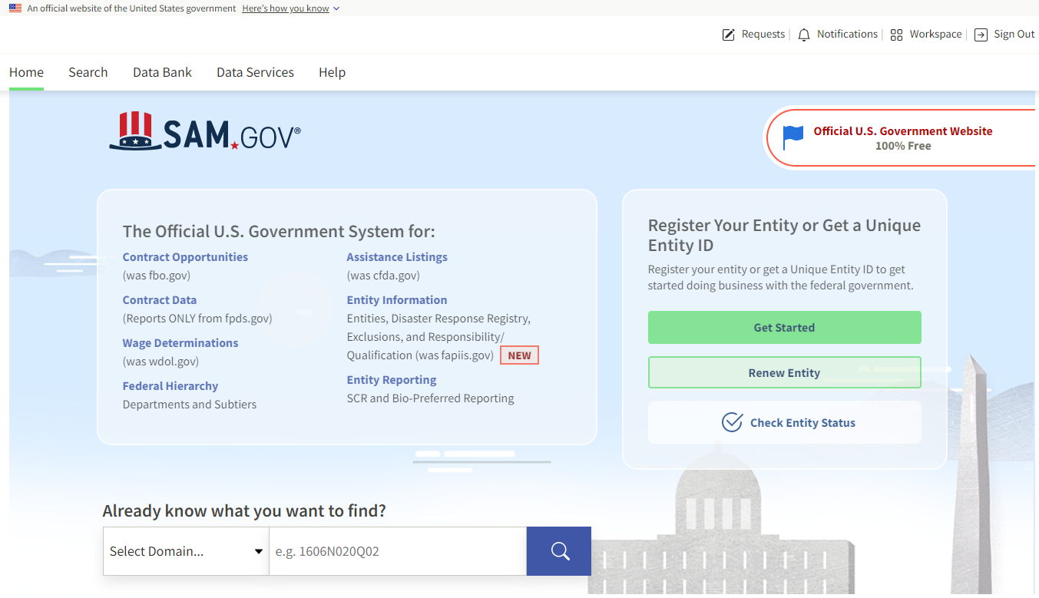

- Ensure “All Entity Information” is selected from the drop-down menu
- Type in Entity or Vendor Name and click search
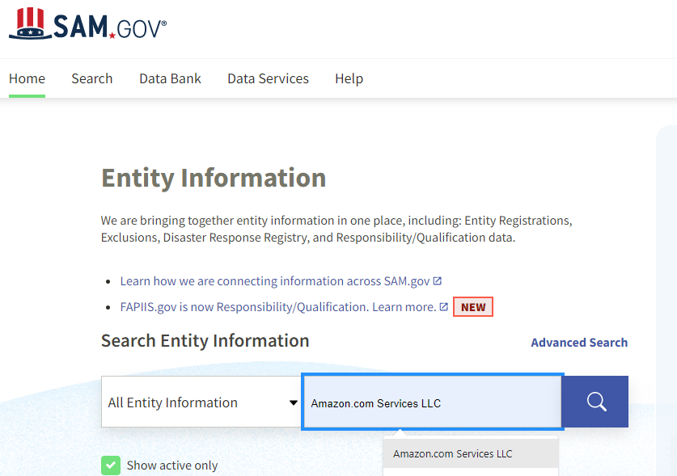

- Click on Vendor name highlighted in blue

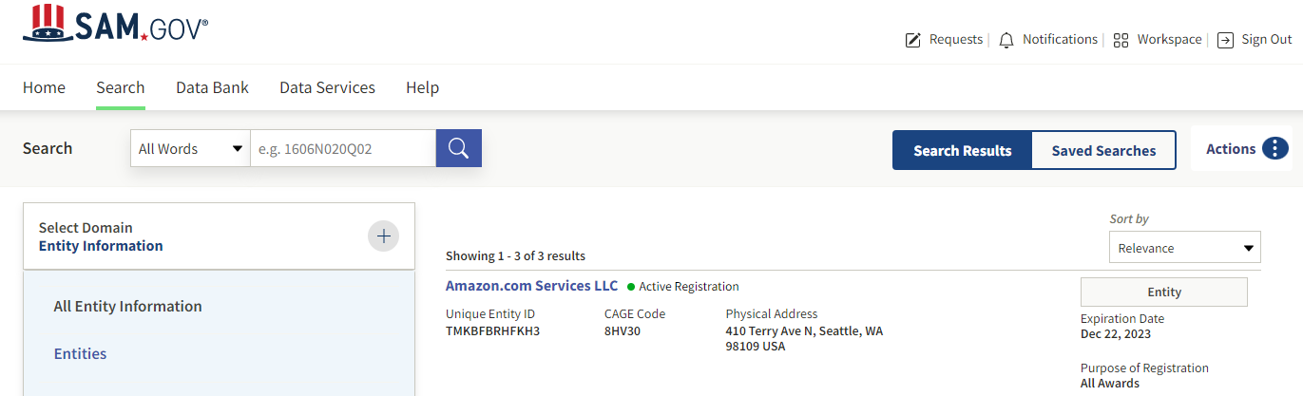

- Click on “Reps and Certs (FAR/DFARS)”
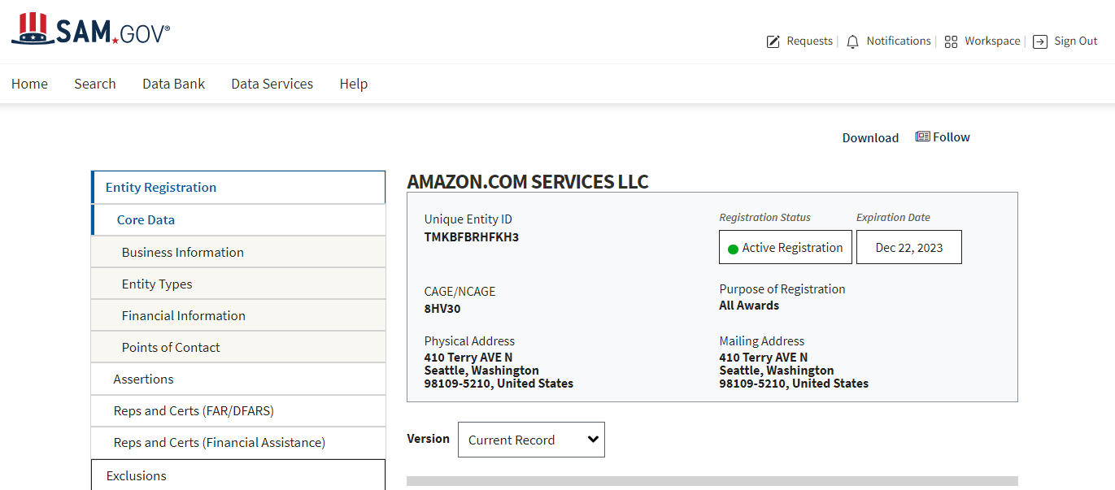

- Click drop down to Download Reports

- Select “FAR” from drop down options

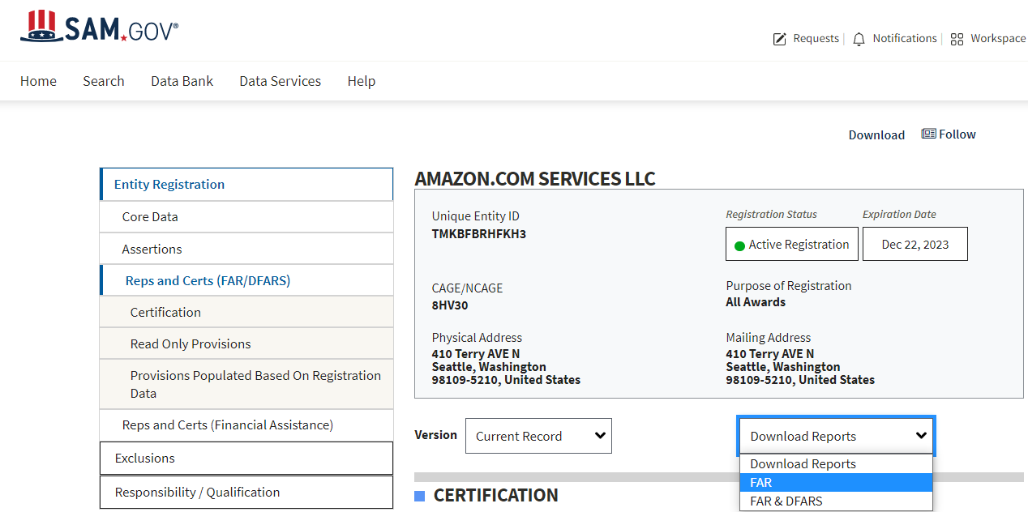

- Pop-up window will display with download options

- Click “Select File Type .pdf”

- Click Download Reports and PDF will open
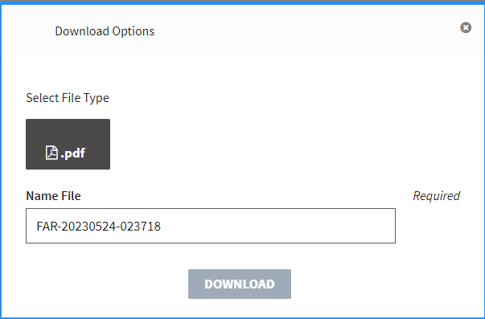

- When PDF opens select Ctrl F and type in FAR 52.204-26 to find Representation
