Downloading the steel docket metadata from regs.gov

- On https://www.regulations.gov/, search for BIS-2018-0006
  - Alternatively, use this link to skip steps 1-3: https://www.regulations.gov/docketBrowser?rpp=25&so=DESC&sb=commentDueDate&po=0&D=BIS-2018-0006
- Click on “Open Docket Folder” on the top-right of the search results

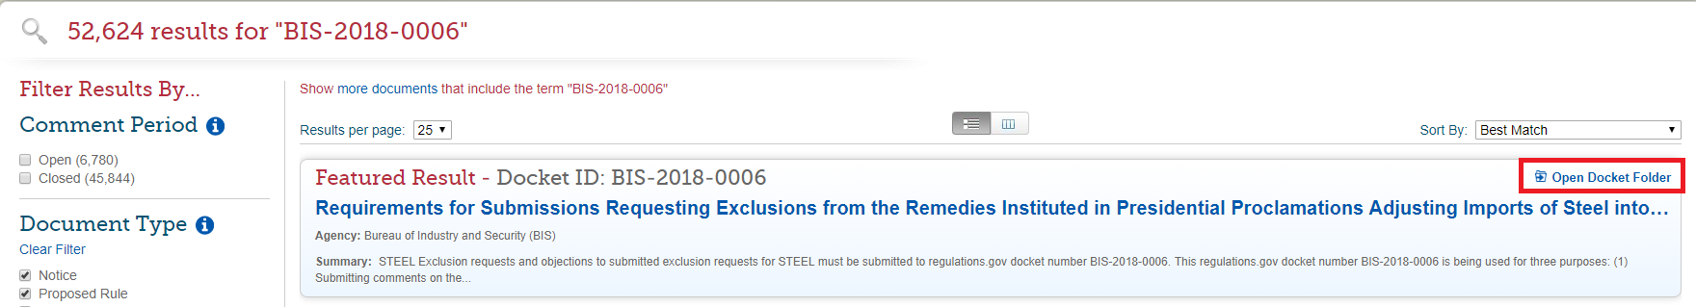

- On the docket folder page, click “View all documents and comments in this Docket” just below the page title

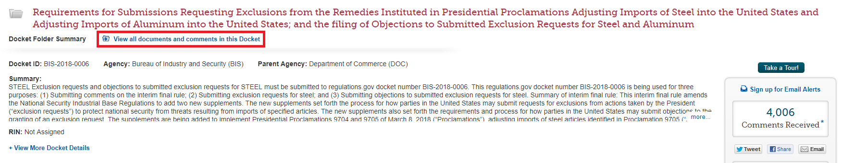
- Click on “Export” in the middle-right of the page
  - Note that regulations.gov caps downloads at 103,000 lines of data – so you will have to download the steel docket in two chunks

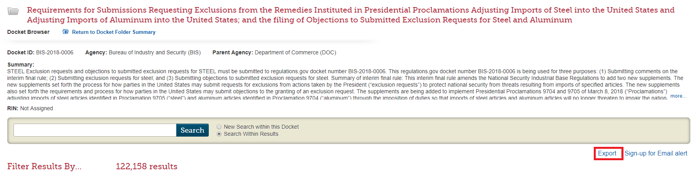

- A box will open; click the option to “Export Selected”, then check the box for “Other” to download steel docket exclusion requests

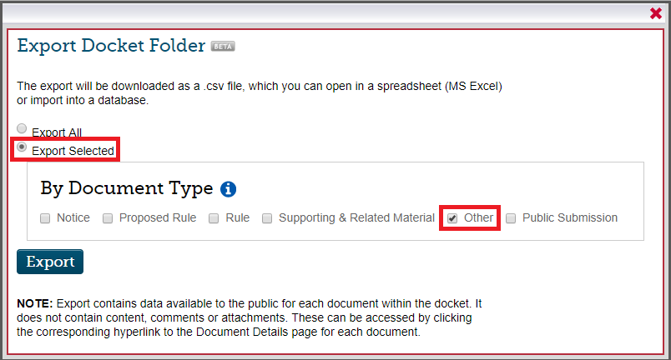

- Wait for the .csv file to download, then click the export button again, select “Export Selected” and this time check “Public Submission” to download steel docket objections, rebuttals, surrebuttals, and decisions

