Department of Commerce
Standard Operating Procedure
GSA Section 889 Easy Search Tool

Purpose: The purpose of this Standard Operating Procedure (SOP) is to provide instructions to assist cardholders with searching for vendor Section 889 Representations before making purchases from open market sources. Steps to Search GSA Section 889 Easy Search Tool:
- Go to Section 889 Easy Search Tool
- Scroll down and select “Section 889 Easy Search Tool”
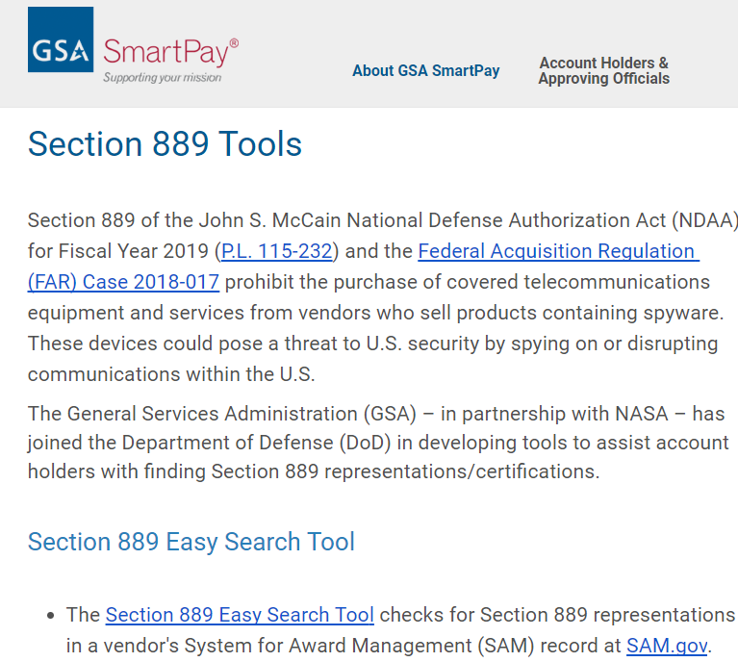
- Search by business name, website, CAGE code, or SAM Unique Entity ID and click Search
- Hoover over blue arrow and click to download PDF
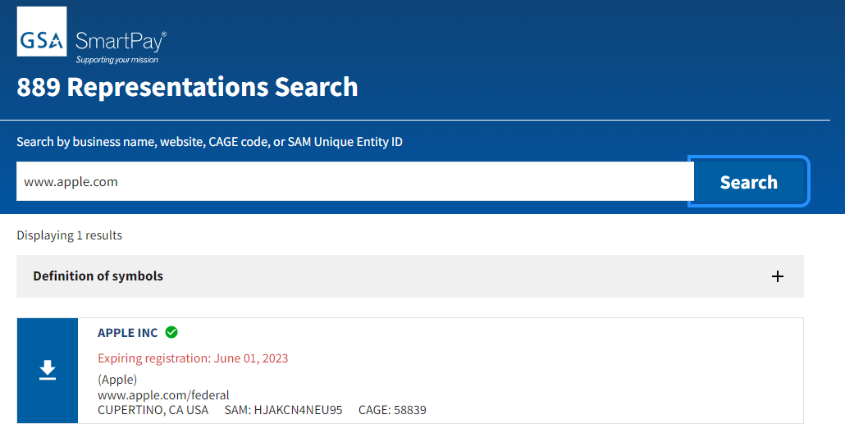

- PDF will open to show entity registration summary compliance and 889 Representation Section

